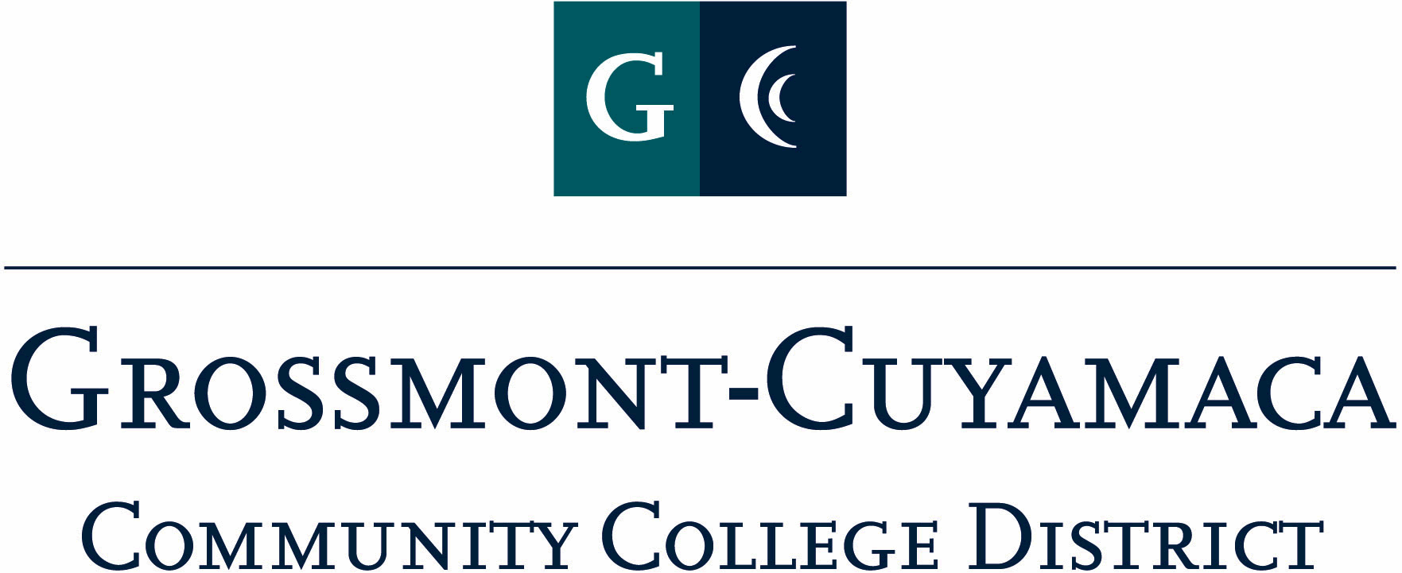

AGENDA

EXECUTIVE BOARD MEETING

Tuesday, December 3, 2013

12:00p – 1:00p
Locations: DLC (x-7399), CC- I 107 (x2758) (Teleconferenced)
Attendees: Executive Board

Meeting Called to Order: Meeting Adjourned:
Agenda
# Item Time

CALL TO ORDER

Call to Order 5 minutes
  - Agenda additions/deletions/changes
  - Approval of Minutes

- ACTION ITEMS
- Web Link – Kerry Kilber Redman http://www.cuyamaca.edu/redesign/
- Chancellors/Classified Senate Award
- CSAD-Committee participation:
Food
Facilities
Workshops & Entertainment
Public Relations
Raffle/Donations
Fiscal Coordination
3 minutes
- COMMUNICATIONS
  - President 3 minutes
  - Grossmont 2 minutes
  - Cuyamaca 2 minutes
  - District 2 minutes
  - Treasurer 2 minutes 3 minutes
- OPERATIONS/TABLED ITEMS/UPDATES
See’s Candy
Holiday Photo
3 minutes

- ITEMS FROM THE FLOOR

!! MERRY CHRISTMAS AND HAPPY NEW YEAR !!

Additional Instructions: Next meeting January 7th

